|  |  |
| --- | --- |
| Course Name: Diploma in Software Engineering and Design | **Student’s name:**  Rupinder Singh |
| **Testing For** | **Video Rental System** |
| **Date of Submitted**: | **12th** Dec 2018 |
| **Github Link** | [**rupinder8699/VideoRentalSystem**](https://github.com/rupinder8699/VideoRentalSystem) |

|  |  |  |
| --- | --- | --- |
| **Functionality** | **Test Scenario** | **Result (Pass /Fail)** |
| Adding Movies | * *Add a Movie and check if it adds to the database and shows in the Data-grid* * *The user should not be able to add the same movie twice, the system should give appropriate error message* * *The system should not store a Blank Movie* * *Movie Genre should have proper value* | Pass  Fail  Pass  Pass |
| Adding Customers | * *Add a customer and check if it adds to the database and shows in the data-grid* * *The system should not store a blank customer name* * *Customer name should not accept special characters or numbers* | Pass  Pass  Fail |
| Search Movies / Customer | * *Search by Movie name / Customer name* * *Search should give out all results that matches the search criteria* | Fail  Fail |
| Update Movies / Customer | * *Should update details of the respective movie and customer only* | Pass |
| Delete Movies | * *Should not be able to delete a movie that is rented out* | Pass |
| Delete Customer | * *Should not be able to delete a customer that has rented out a movie* | Pass |
| Issue Movie | * *Issue a movie to a customer and check if it adds a record in the Rented movies table, Date rented should be the current system date* * *System should not issue a movie that is already been rented out* * *Give an error message if there are no copies of the movies* * *Cannot issue more than two movies to the same customer* | Pass  Fail  Pass  Fail |
| Return Movie | * *Return movie should update the Rented Movies Table* * *Cannot return a movie that has not been rented out* * *Date returned should reflect the current system date in the Rented movies table* | Pass  Pass  Pass |

Adding Movies

* *Add a Movie and check if it adds to the database and shows in the Data-grid*

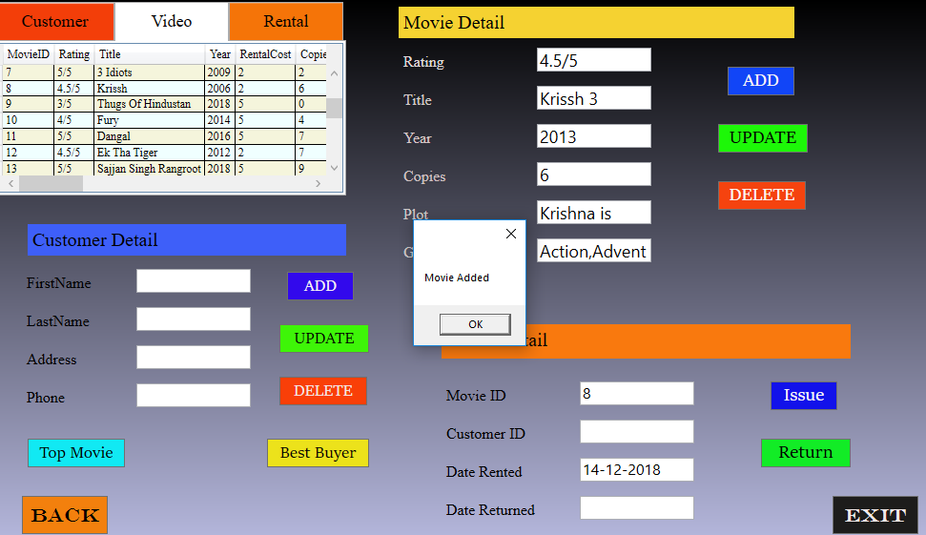

* *Movie Genre should have proper value*

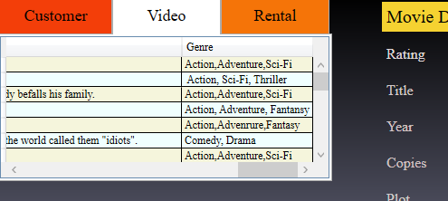

Adding Customers

* *Add a customer and check if it adds to the database and shows in the data-grid*

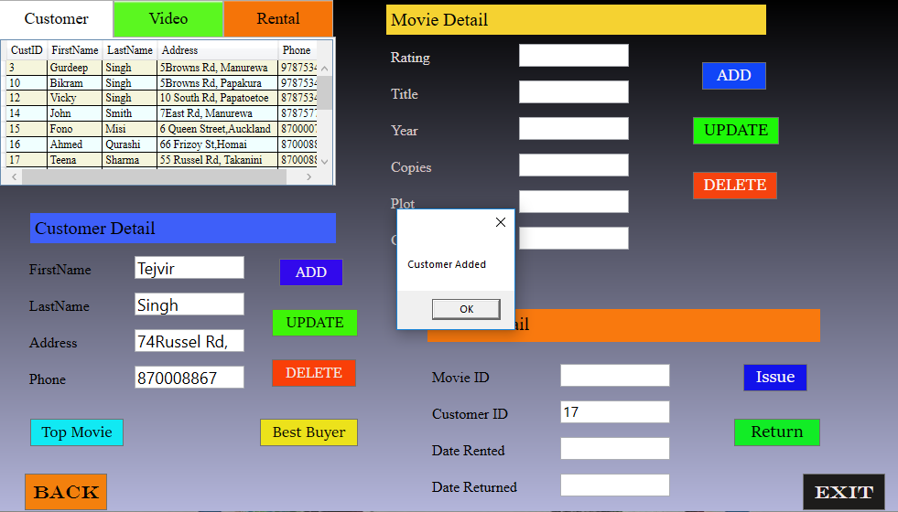

Update Movies / Customer

*Should update details of the respective movie only*

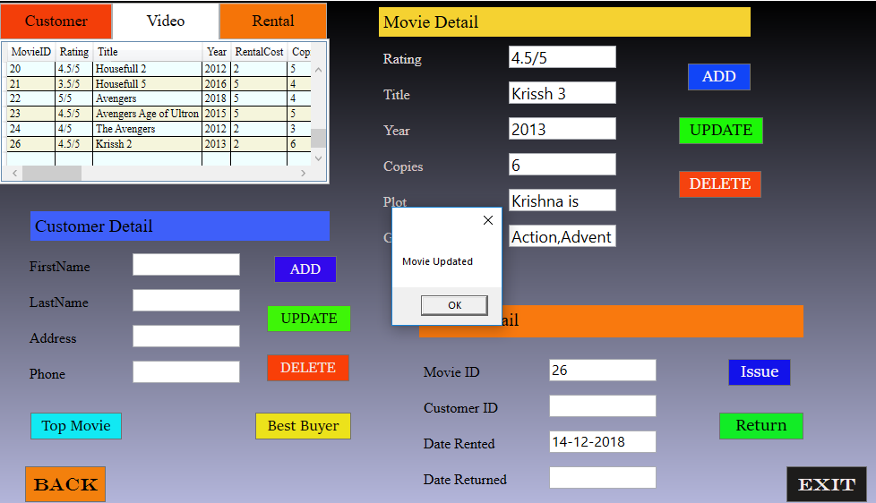

*Should update details of the respective customer only*

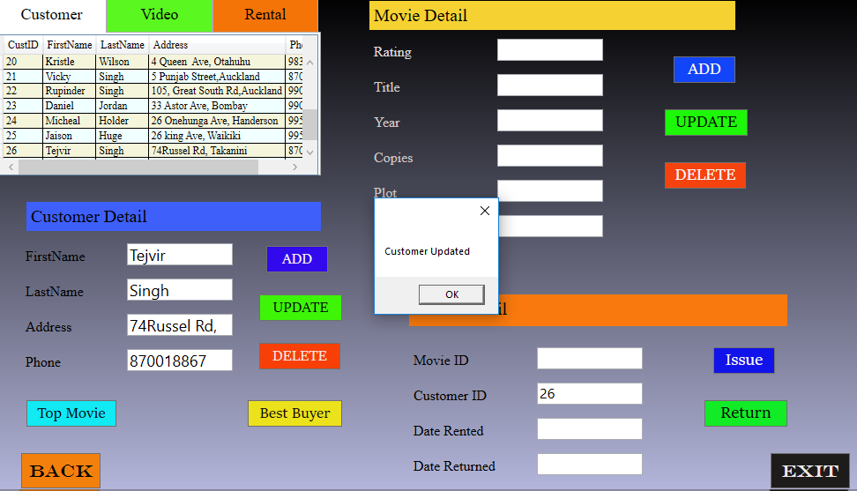

Delete Movies

*Should not be able to delete a movie that is rented out*

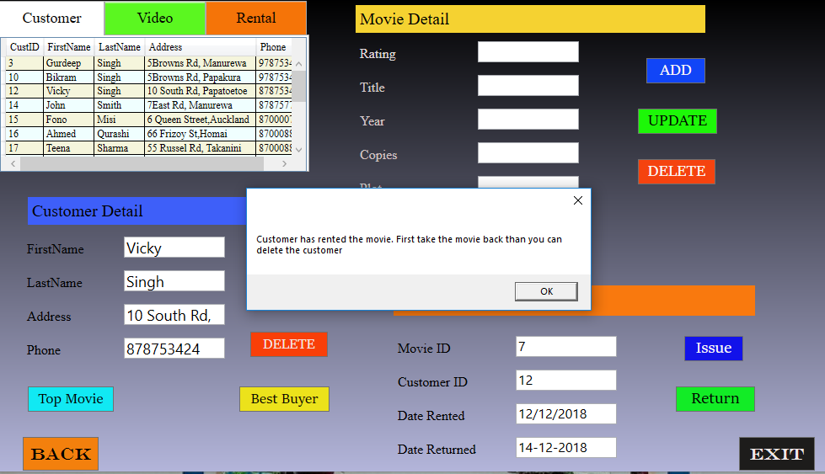

*Should not be able to delete a customer that has rented out a movie*

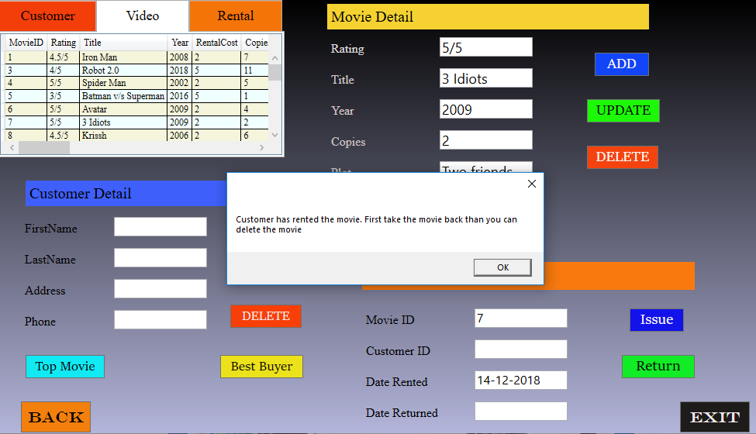

Issue Movie

* *Issue a movie to a customer and check if it adds a record in the Rented movies table, Date rented should be the current system date*

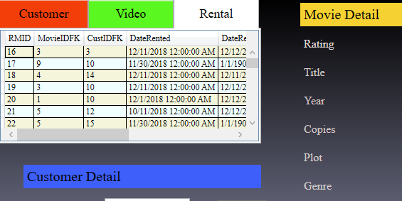

* *Give an error message if there are no copies of the movies*

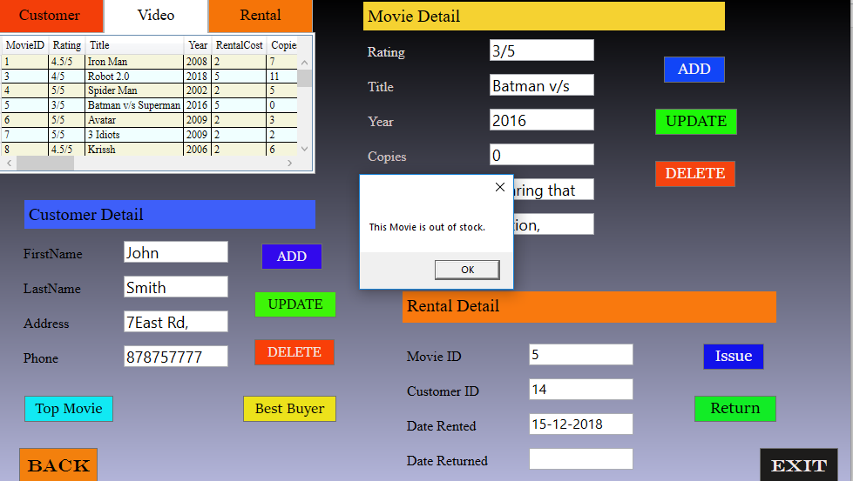

Return Movie

* *Return movie should update the Rented Movies Table*

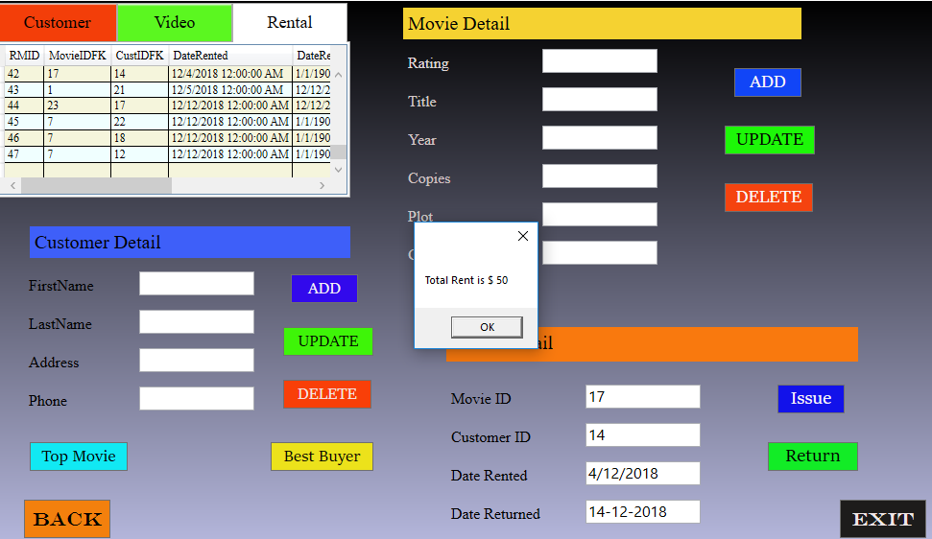

* *Date returned should reflect the current system date in the Rented movies table*

